**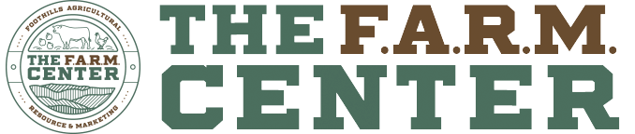****2022 SCFHF Dairy Cattle Show Rules**

**September 23, 2022**

**4:30 PM**

*Entry fees are $10 per head if post marked by Friday, September 9, 2022. Entry fees postmarked after September 9, 2022 will be $20 per head.

*HEALTH papers are **REQUIRED** for ALL out of state cattle. Cattle not crossing state lines are not required to have health papers.

*Check in will be 12:00 Pm – 4:00 PM on Friday September 23. The show will begin at 4:30 Pm.

*NO stalling area. Cattle will be safely tied to trailers or tie out area.

*Wash facilities will be available, BUT no electricity-bring a generator.

\***Showmanship** ages are determined as of January 1, 2022.

** Ages 8 & under

** Ages 9-11

** Ages 12-13

** Ages 16-18

\***Dairy breed shows will be:**

**All Dairy breeds will show together**

**\*Breed Show:**

Junior Calf- born March 1, 2022- May 31, 2022

Intermediate Calf- born December 1, 2021-February 28, 2022

Senior Calf- born September 1, 2021- November 30, 2021

**Calf Champion/Reserve Calf Champion**

Summer Yearling- born June 1, 2021- August 31, 2021

**Show Contacts**

**Shawn Smith**- 864-634-3233

[smithscorral@att.net](mailto:smithscorral@att.net)

**Tara Rogers**- 864-276-4512

[tarabreanne15@gmail.com](mailto:tarabreanne15@gmail.com)

Junior Yearling- born March 1, 2021- May 31, 2021

**Jr. Champion/Reserve Jr. Champion**

Intermediate Yearling - born December 1, 2020-February 28, 2021

Senior Yearling – born September 1, 2020 – November 2020

**Senior Champ/Reserve Senior Champ**

**Overall Grand Champion**

**Overall Reserve Grand Champion**

