The Foothills Agricultural Resource & Marketing Center
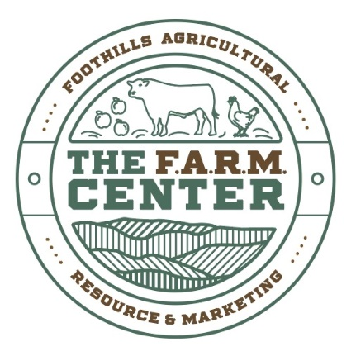
The FARM Center is a 501(c)3 Organization

Mailing Address: Physical Address:
P.O. Box 130 2063 Sandifer Blvd.
Richland, SC 29675 Seneca, SC 29678
Website: www.farmoconee.org Email:farmcenterseneca@gmail.com

Sponsorship opportunities:
Banners: The banners will be prominently displayed along Sandifer Blvd, where over 35,000 cars pass by daily, providing excellent visibility for your message. Additionally, The FARM Center attracts more than 30,000 patrons annually to its various events, offering ample exposure to your brand or message.
4X6 or 5X5 $350/yr.
To reserve your space, complete the attached form and return it to The FARM Center following directions provided below.
Please contact Abigail Gibson (864) 539-2221 abigailgibson.tfc@gmail.com if you have any questions.

The Foothills Agricultural Resource & Marketing Center
The FARM Center is a 501(c)3 Organization

Mailing Address: Physical Address:
P.O. Box 130 2063 Sandifer Blvd.
Richland, SC 29675 Seneca, SC 29678
Website: www.farmoconee.org Email:farmcenterseneca@gmail.com

Banner Sponsorship Form: (Please Print)
Business Name: ___________________________________________________________
Address: _________________________________________________________________
Contact Name: ____________________________________________________________
Email: ___________________________________________________________________
Phone: ____________________________
Check the sponsorship opportunity in which you will be participating:
____ 4X6 or ____5X5 Banner ($350)
Total amount due: $_______________
Payment may be made by returning this form with a check made payable to:
The FARM Center
PO Box 130
Richland, SC 29675

High quality jpeg or pdf digital copies of any logo or other material required for the Banner will need to be emailed to abigailgibson.tfc@gmail.com.

